Vending Machine
What type of test (Boundary or expected/Unexpected | Test Input | Expected output | Actual Output | Pass/Fail | If it fails (Y/N) | What did you do to fix it | Screenshot Evidence
Expected/ Unexpected | 2  5.67 | Enjoy your Chocolate! Your change is $3.17. | Enjoy your Chocolate! Your change is $3.17. | pass | N | N/A | 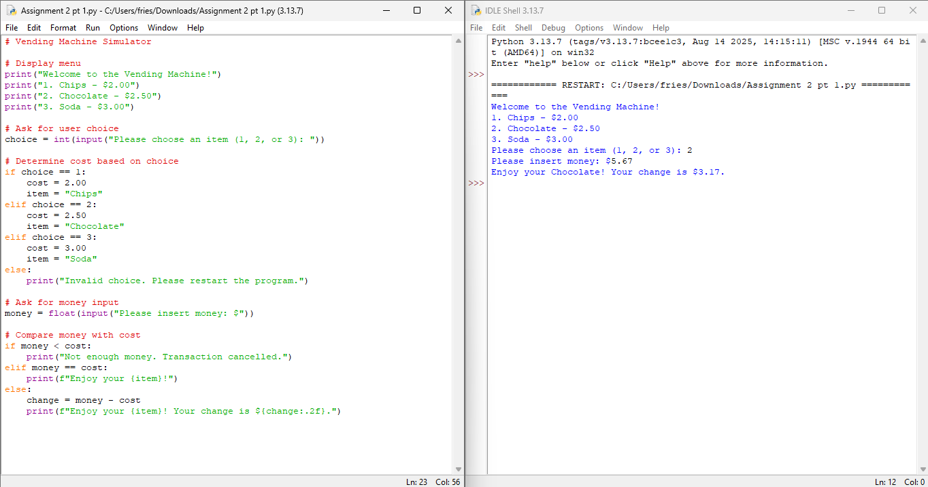
boundary | 1  1.99 | Not enough money. Transaction cancelled. | Not enough money. Transaction cancelled. | pass | N | N/A | 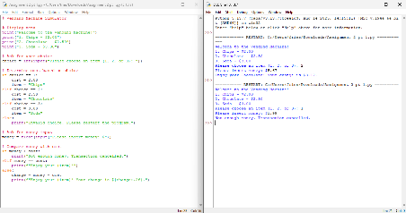
boundary | 3  3.00 | Enjoy your soda | Enjoy your soda | pass | N | N/A | 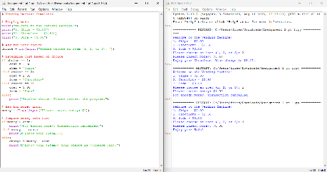

Movie Ticket
What type of test (Boundary or expected/Unexpected | Test Input | Expected output | Actual Output | Pass/Fail | If it fails (Y/N) | What did you do to fix it | Screenshot Evidence
Expected/ Unexpected | 3  no | Your ticket price is: $ 8 | Your ticket price is: $ 8 | pass | N | N/A | 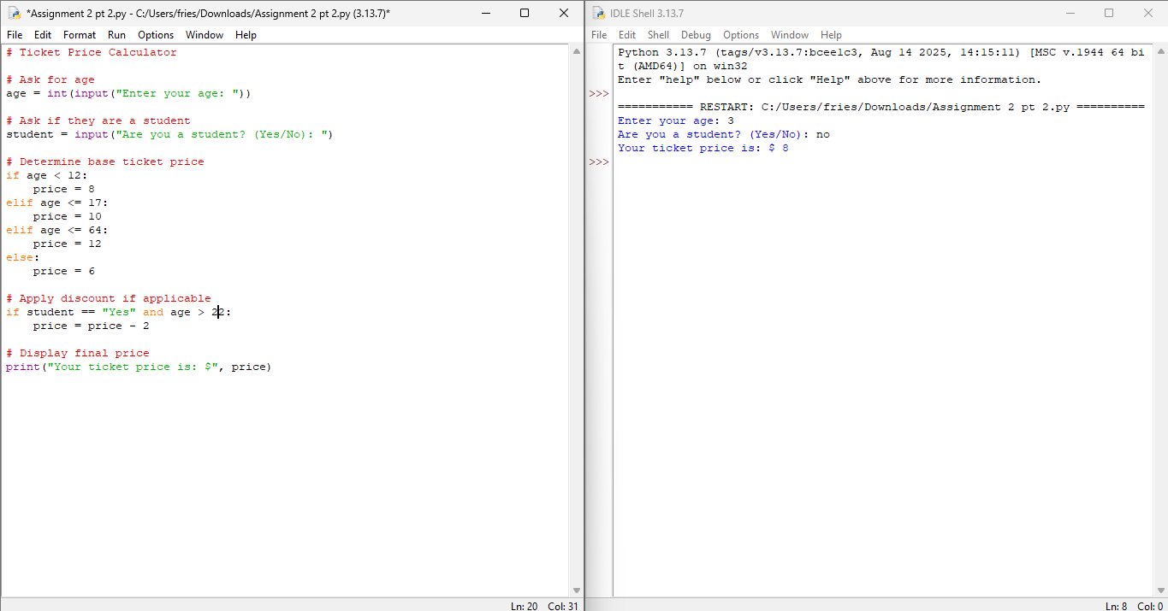
boundary | 16  yes | Your ticket price is: $ 8 | Your ticket price is: $ 10 | Fail | Y | I see that the discount was mis tpyed to be 22, instead of 12, so I will change it | 